Peter Noack, Zeitgeist Asset Management: interest in rental housing to increase sharply in Czech Republic

Prague, 25 March 2019

**The Czech Republic is among the countries with the lowest share of rental housing in the EU. According to the statistical office of the EU (Eurostat), home ownership still dominates the market with a share of 78%, while rental housing only has 22%[1]. Meanwhile, in the neighbouring countries (Germany, Austria) the share of rental housing is roughly double[2]. The interest in rental housing in the Czech Republic, however, is expected to increase significantly this year, following the current trends in the neighbouring countries, explains Peter Noack, CEO of Zeitgeist Asset Management. Zeitgeist is a Real Estate Developer and Asset Manager for private and institutional investors in the Czech Republic, Germany, Poland and Hungary. In Prague, it is currently planning to create a portfolio for 500 rental flats in various localities and with a range of different standards. At the same time, it is bringing a new standard of student housing in modern reconstructed buildings to Prague and, following its success in the Czech Republic, it is preparing the same model in Poland, specifically in Warsaw.**

**The more expensive the flats, the greater the interest in rental housing**

Even though living in your own flat is very popular and underscores the social position of the owner, many Czechs will have to forego this in the coming years. This can be due to a variety of different factors. *“The significant and continuing increase in the prices of flats in Czech Republic’s largest cities, the continuing rise in interest rates, the tightening conditions for mortgages by the Czech National Bank, and the expected wage moderation – will all elicit a high demand for rental housing. This segment of the real estate market especially offers huge potential in Prague. The prices of new flats in the capital city have, in many cases, surpassed the magic threshold of CZK 100 000 per square metre, and thus rental housing will be the most popular alternative to ownership. Just consider, that you have to be prepared to pay an equivalent of almost 17 net average annual salaries, in order to purchase a flat in Prague with the most popular size of two rooms and a kitchenette and approximately 60 sqm,”* stated Peter Noack. According to the 2018 Property Index study from Deloitte consulting company, which analysed the residential markets in 12 European countries, Czechs have to save the longest of all the compared countries for new housing - longer than the citizens of Great Britain, France or Germany, for example.

**Rental housing is not just for students anymore, but also for the middle class**

*“With the boom of ownership in the Czech Republic, rental housing was psychologically perceived as typical for the less wealthy or students, though not for the middle class. This, however, will probably change in the near future, because a great number of people in the middle class will no longer be able to afford owning their own flat. Rental housing, however, also has its share of advantages such as greater flexibility when moving and the fact that the tenant does not have to worry about repairs.* *Plus, research shows that the millennials, which should make up the greater part of the population at a productive age by the year 2025, prefer rather to invest their money into experiences and hobbies than into bricks,”* Peter Noack said.

**Germany: rental housing – quite common in cities**

Unlike the Czech Republic, people in neighbouring Germany see rental housing as something completely natural. *“Every second German lives in rental housing and this applies across the age spectrum, from singles and families with children to senior couples. In the Czech Republic, on the contrary, rental housing is currently most frequently used by people up to 30 years of age,”* commented Peter Noack. Rental housing has a long tradition in Germany: during the 2nd world war more than half of the housing space was destroyed, so in the post-war period it was necessary to provide new housing for the growing number of inhabitants, and this was primarily rental housing. The share of ownership here is currently 46% and less than 30% in all larger cities.[3] According to data from Zeitgeist Asset Management, it is only a mere 15% in the capital city of Berlin. *“Today there is great interest in rental housing in the German cities. Thus, the tenants usually have to submit documentation of their income and a confirmation of solvency to the landlord. When there are more people looking to rent a flat, a reference from a previous landlord is an advantage. The standards of German rental housing are up to a good level thus Germans do not have to invest into their own flat in order to live well. Another detriment to ownership in Germany is that the fees connected with the purchase of property are relatively high (the property transfer tax plus notary fees can total up to 15% of the price including taxes),”* pointed out Peter Noack.

**Poland: prices of rent comparable to Germany**

Most of the inhabitants in Poland prefer living in their own flat, with their share rising by roughly a fifth in the last ten years.[4] Thus, more than 83% of Poles live in their own house or flat. *“In addition to the historical experience with the expropriation of property during the Communist period, this trend is currently also influenced by the high rents, which are comparable to Germany,”* commented Peter Noack.

**Hungary: share of ownership is high, but dropping**

In comparison with the Czech Republic, Poland and Germany, the share of those who live in their own flat is highest in Hungary (exceeding 85%), but it has constantly decreased since 2012, when the share of ownership hit its peak (around 90%). *“In Hungary rental housing is most often used by people aged 18-35 as well as those who frequently move because of their work,”* concluded Peter Noack.

**INFOGRAPHIC**

***Share of rental housing and ownership in overall stock of housing***

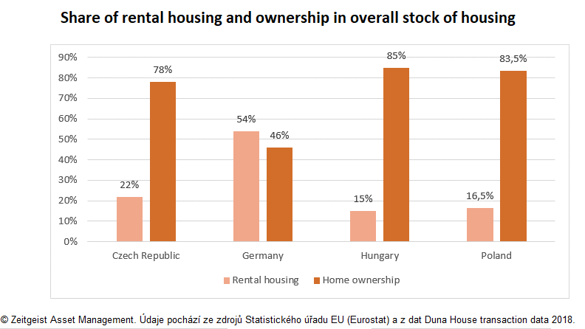

***Rental housing vs. ownership: how long would a person have to pay rent before they could afford to buy their own flat***

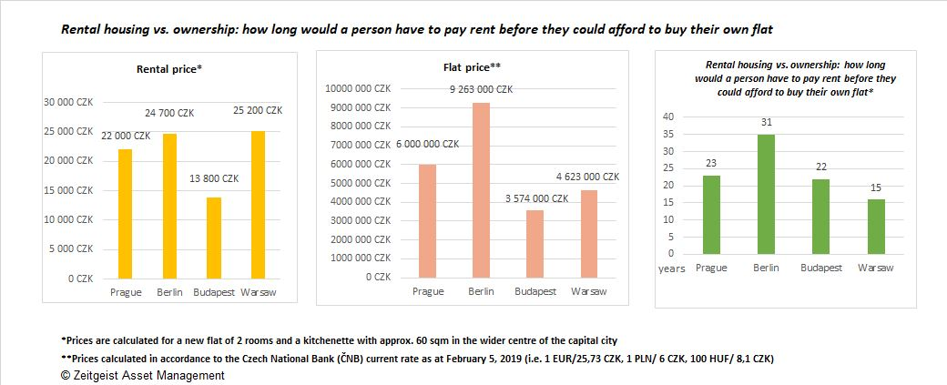

**About Zeitgeist Asset Management**

*Zeitgeist Asset Management, with offices in Prague, Warsaw and Berlin, is a Real Estate Developer and Asset Manager for private and institutional investors in the Czech Republic, Poland, Hungary and Germany.*

**For more information please contact:**

**Dagmar Schejbalová, Kamila Čadková**

Crest Communications

Tel.: +420 775 899 353, +420 731 613 609

E-mail: [dagmar.schejbalova@crestcom.cz](mailto:dagmar.schejbalova@crestcom.cz)

[kamila.cadkova@crestcom.cz](mailto:kamila.cadkova@crestcom.cz)

Web: [www.crestcom.cz](http://www.crestcom.cz)

**Ivona Kapinusová**

ZEITGEIST Asset Management, s.r.o.

Tel.: +420 221 864 140

E-mail: [ivona.kapinusova@zeitgeist.re](mailto:ivona.kapinusova@zeitgeist.re)

Web: [www.zeitgeist.re](http://www.zeitgeist.re/)

1. See <https://ec.europa.eu/eurostat/documents/3217494/9079352/KS-DZ-18-001-EN-N.pdf/884f6fec-2450-430a-b68d-f12c3012f4d0>, p 56.
2. Ibid.
3. Export to SRN, 31.8.2018: <https://www.exportdosrn.cz/article/polovina-nemcu-bydli-v-najmu/>
4. Money.pl, 7.11.2017: <https://www.money.pl/gospodarka/wiadomosci/artykul/wlasnosc-mieszkania-wynajem-europa,85,0,2385749.html>