
PRESS RELEASE Prague, 2 July 2019

Not even rain could ruin the traditional concert in BB Centrum

This year’s annual concert in BB Centrum, which has already become a tradition, took place on Thursday 20 June. The bands Slza and Xindl X played in Baar Park, plus all afternoon and evening there were entertaining activities prepared for children and adults as well as refreshment stands.

The concert commenced with Maranatha Gospel Choir oriented on gospel music, which pleasantly set the mood for the approximately 2500 people in the audience. Then Slza took the stage to play most of its best-known hits and at the end of the evening Xindl X performed with his guitar and some special guests. Not even the rain that briefly fell during the course of the evening could ruin the atmosphere.

“The concert was a huge success with the audience, for which we are understandably delighted. Plus it is only one of the many events that we regularly hold in BB Centrum for tenants and people both near and far. We are glad that we can draw attention in this manner to the opportunities that the complex offers, to present the local green spaces and restaurant services while moreover entertaining the audience free of charge, because all the expenses for the event are covered by Passerinvest Group. Our goal is to make the visitors’ stay in BB Centrum more pleasant, and we are very glad that they regularly return to us. This year’s concert had a fantastic atmosphere and we are already looking forward to next year,” commented Vladimír Klouda, the Executive Director of Passerinvest Group, with regard to the event.

Children could compete in contests as part of the accompanying activities and refreshments were prepared for all by the local restaurants. A street food festival featuring tastes from all over the world was prepared for the attendees on Brumlovka Square.

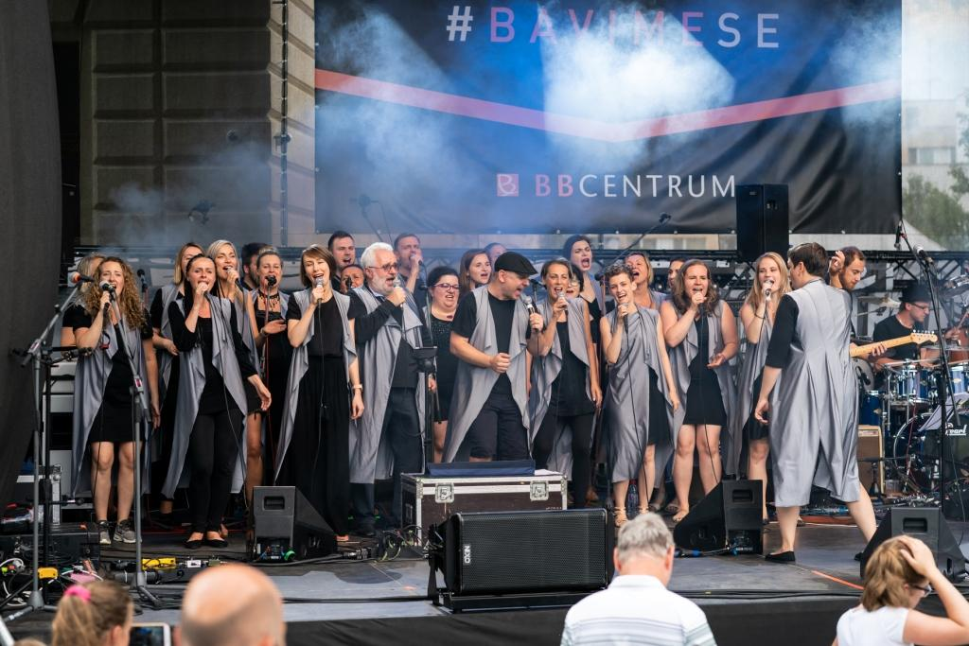

The concert in BB Centrum was begun by the Maranatha Gospel Choir.

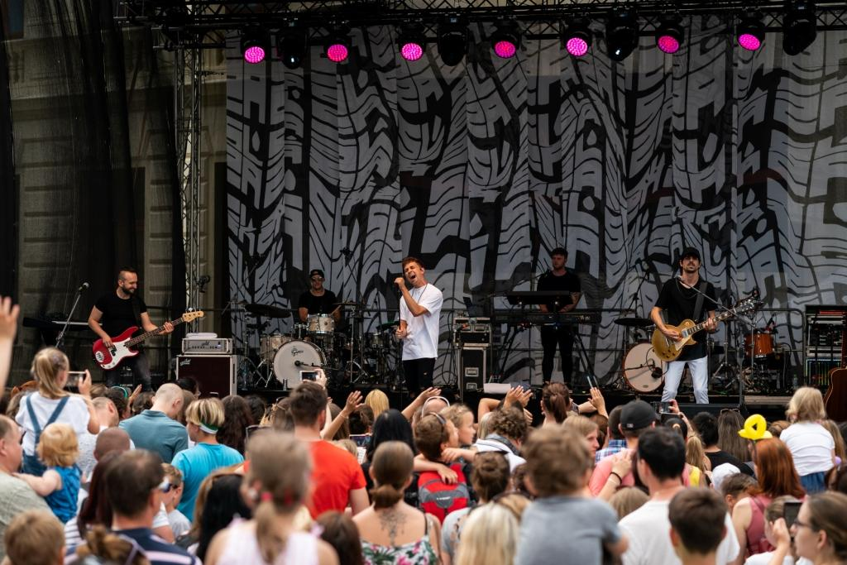

The second performer in the concert in BB Centrum was the group Slza.

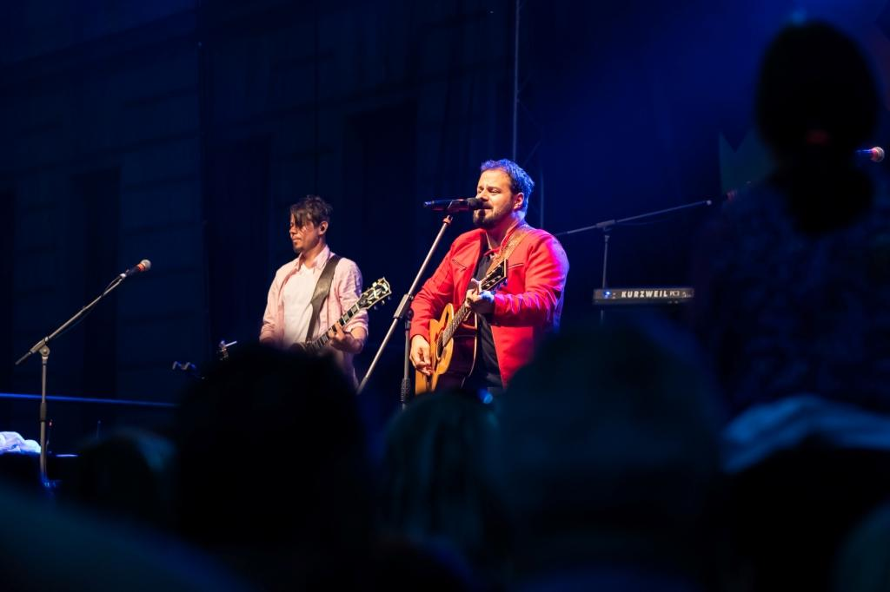

Xindl X closed out the concert in BB Centrum in Prague 4.

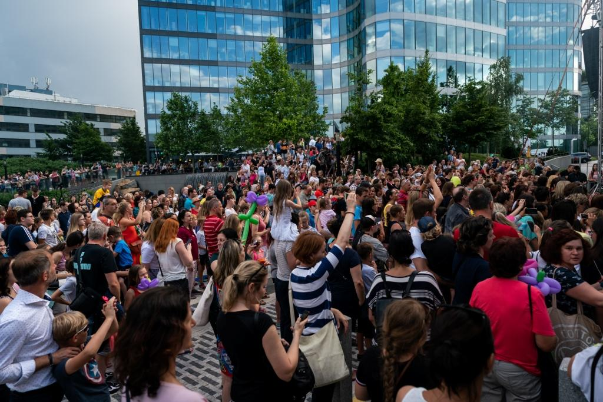

There was a fantastic atmosphere during the entire concert in BB Centrum and the audience had a great time.

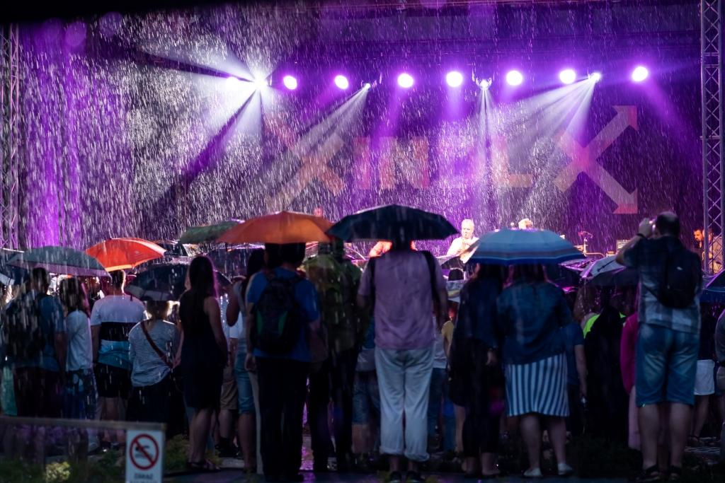

Not event rain, due to which the event in BB Centrum had to be interrupted for a few moments, could dampen the audience’s spirits.

You can get more information and photographs in print quality from:
Kristýna Samková, Head of PR and Marketing Department
PASSERINVEST GROUP, a.s.
Tel.: (+420) 221 582 111
E-mail: Kristyna.Samkova@Passerinvest.cz
www.passerinvest.cz, www.bbcentrum.cz

Marcela Štefcová
Crest Communications a.s.
Mobile: (+420) 731 613 669
E-mail: marcela.stefcova@crestcom.cz

About the company

PASSERINVEST GROUP, a. s., is a purely Czech development and investment company, whose name is primarily connected with the realisation of the multifunctional BB Centrum complex in Prague 4 – Michle. The company, established by Radim Passer in 1991, built a very good reputation both on a local and international level with this, the most successful and extensive project of its kind in Central Europe. This is not only to the credit of the quality of the realised projects and the high level of the provided services, but also due to the sense of fair play, an accommodating relationship with the buildings’ tenants/users and responsibility to the society and the environment. Ve svém portfoliu má PASSERINVEST GROUP also has other interesting investment and development projects in its portfolio, as well as projects that serve the general public and inhabitants of Prague.

