**How do Central Europeans shop? The CBRE Study brings a unique detailed probe**

Prague, 7th October 2019 — CBRE, a global leader in the field of commercial real estate services has conducted an extensive survey of retail real estate market focusing on the CEE region. The result is unique data arising **from the analysis of 180 regional shopping centres in the Czech Republic, Poland and Slovakia, which represent almost 4.5 million sqm of retail space and over 1 billion customers in 2018**. During preparation, CBRE used its long-term experience and number one position in the field of property management and leasing of retail space, when it mediated the lease of 350,000 sqmof retail space in the CEE region in the last year.

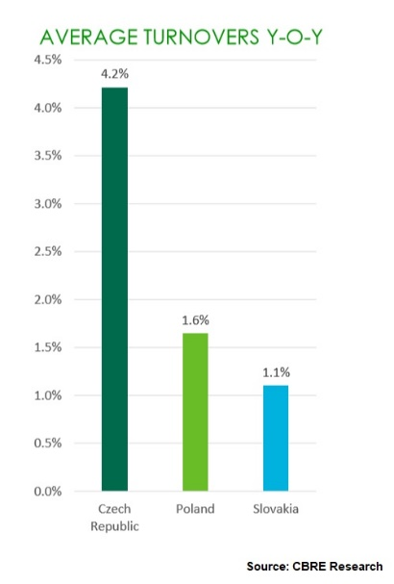

*“Positive GDP development, falling unemployment and growing average wages were reflected in the significant growth of household purchasing power and spending for retail. As a result, turnovers in shopping centres grew in 2018 either. The highest year-on-year growth was in the Czech Republic (4.2%), followed by Poland (1.6%) and Slovakia (1.1%). Average turnover grew despite newly implemented sales restrictions on Sundays and public holidays in Slovakia, and also despite the dynamically developing world of e-commerce,”* comments **Katarína Brydone, Head of Retail at CBRE**, and adds: *“In the upcoming years, the dynamics of e-commerce growth is expected to slow slightly. In 2023, we expect its share to stabilize at 17% in the Czech Republic and 10% of total sales in Poland and Slovakia.”*

**The purchasing power of the CEE region allows to build a dense network of stores**

Central Europeans are still shopping, and they will continue to make the most of their purchases in physical stores. The Czech regional market has been stabilized for several years with the minimum of new retail space, or in exceptional cases, there were mainly expansions of existing shopping centres. In the future, the trend of almost zero construction will continue. The offer of the centres is stabilized, and the centres are being modernized. Although the current density of 174 sqm retail space per 1,000 inhabitants in the regions of the Czech Republic can be considered high, it is even higher among our neighbours. In the Polish regions, it is around the level of 216 sqm per 1,000 inhabitants and in the Slovak regions, it is 178 sqm per 1,000 inhabitants. The rapid construction, which was in the first twenty years after the revolution, is receding and the CEE markets are now mature. Therefore, construction in the CEE is limited and currently 4% of the total volume of shopping stock is being under construction, i.e. 297 thousand sqmin the Polish regions and 38 thousand sqm in the Slovak regions.

*“In the Czech regions, the current construction is even lower, i.e. 1% of the total volume of retail stock in shopping centres. Great potential for the expansion of shopping centres can be gained in the ongoing remodelling of shopping centres, which is a trend of the present. Especially thanks to the optimization of the area of hypermarkets (so-called downsizing), it is possible to expand the offer of centres with other attractive tenants and to introduce new services. Compared to other CEE countries, the Czech customer has the highest purchasing power in the amount of CZK 235,500 per year. In Slovakia, it is less than CZK 30,000 per person less, i.e. approximately CZK 208,000 per year, and in Poland, it is CZK 181,700,”* says **Klára Bejblová, CEE Retail Research & Consultancy at CBRE**.

**Fashion continues to dominate the centres, but Speciality retail has seen an increase of up to 8% of space in the Czech Republic**

The share of individual sectors in the total area of shopping galleries in CEE did not change significantly in 2018. Fashion occupies the main position with 35 – 42%. Despite this, the biggest year-on-year increase of 4 to 8% was in Speciality retail (for example, perfumery, bookstore, pharmacy, toys or optics). Currently, it is the second most important sector in the Czech Republic (15% share) and in Slovakia (16%). In Poland, Household & Furniture and Electronics occupy the second place with 12%.

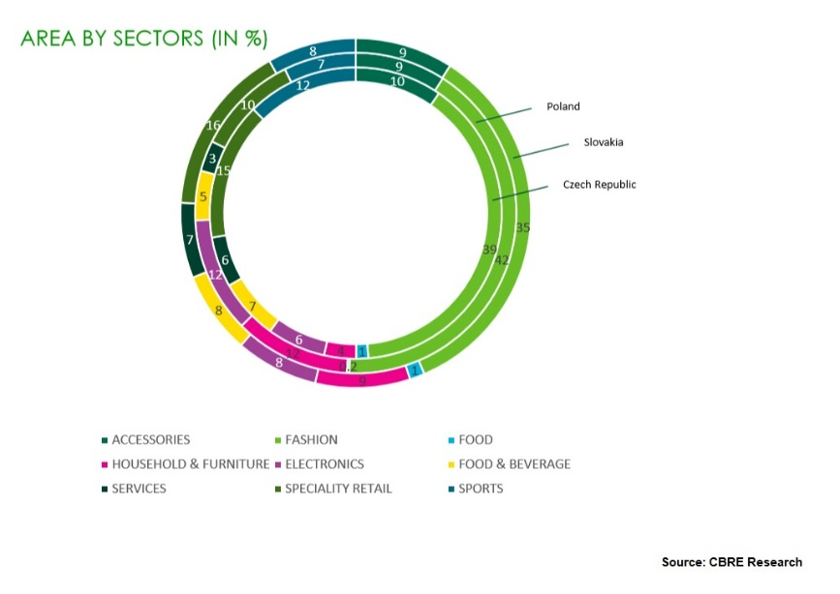

*“The gastronomy sector is also experiencing a significant growth. In the Czech Republic, there has been even a 40% increase of turnover in relative to retail space in the last three years. To the growing popularity of gastronomy responds very well the ever expanding base of concepts. In addition to local retailers who are essential for this sector, there is an increasing interest of international operators. In 2018, gastronomy was the third most active sector with the share of 21% of all newly entering international brands,”* comments **Milan Mašša, Head of Retail Advisory & Transaction Services at CBRE**.

**The value of the average basket and its content vary in the CEE region, but the Czech spend the most**

Shopping centres are most often visited by Slovaks. Shopping is a part of their social life: they love fashion, shoes and accessories. Both Czechs and Slovaks are delighted in buying electronics and sports equipment. Czechs do not visit shopping centres so often, but they spend the most of all the monitored countries. Approximately CZK 210 per visit and per person. The size of the average basket correlates very well with the purchasing power of the population in the given countries. The value of the average basket in Slovakia is approx. CZK 155 and CZK 114 in Poland per visitor. Poles spend the least money on fashion and sports. Conversely, they have the highest spending in the sector of Household & Furniture. They do not hesitate to pay for various services in shopping centres (for example, hairdressing, beauty salons or travel agencies). Spending on gastronomy is comparable to the Czech Republic.

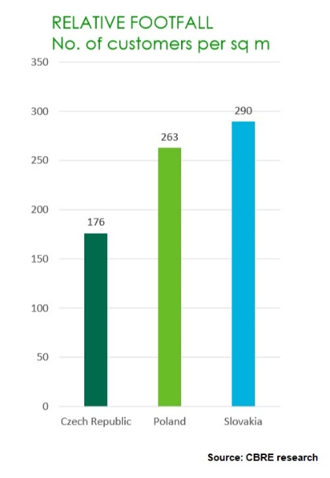 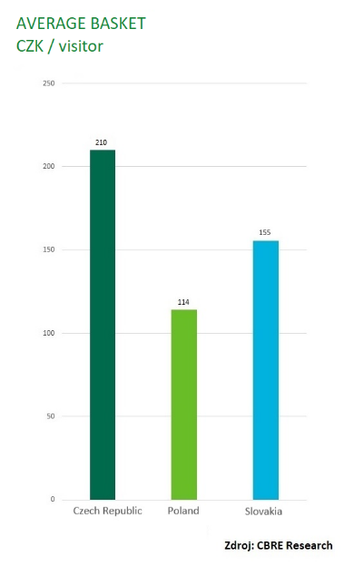

**The average unit size is around 200 sqm, the rent size is influenced by anchor tenants**

While in the regions of the Czech Republic and Poland (apart from capital cities) large-scale shopping centres represent about 30% of the total area, it is less than 10% in Slovakia. This to a certain extent corresponds to the size of retail markets of individual countries. The average size of a leased unit in a shopping centre based on the analysed sample is 227 sqmin Poland, 207 sqm in the Czech Republic and 170 sqm in Slovakia. Among other things, this is influenced by the strong position of anchor tenants who usually rent the two largest categories of retail units (with the size over 500 sqm). Their share in the CEE region represents approximately 50% of the total area of shopping centres.

*“Anchor tenants have a significant influence on the average rent: 56% in Poland, 47% in the Czech Republic and 40% of area of the shopping gallery in Slovakia. The total average rent in Slovakia is approximately 8% higher than in the Czech Republic. The least expensive is renting a retail unit in Poland, where it is 27% more favourable than in Slovakia and 21% more than in the Czech Republic. This is influenced especially by the lower rental levels in the Household & Furniture sectors and also by its significant 12% share of the total area,”* states **Tomáš Míček, Head of Property Management – Retail at CBRE**.

While the strong centres that underwent remodelling in recent years showed an increase or stability in the overall average rent, the remaining centres declined. The average rent increased year-on-year only in the Czech Republic (1%); it dropped by -1.9% in Poland, which was mostly influenced by the fashion sector (-3.8%), and even by -5.5% in Slovakia. In the Czech Republic and Slovakia, there was a significant influence from large anchor tenants (over 1,000 sqm), where the Czech Republic recorded a year-on-year decrease of -6.2% and Slovakia -5.1%.

**The vacancy rate is healthy and the “rent-to-sales ratio” is below the double-digit level**

*“In all monitored countries, the vacancy rate reaches a sound level of 4 – 5%. Thanks to the growth of turnovers, we recorded a year-on-year decline of the “rent-to-sales ratio,“ which was below the double-digit level in 2018. In the Czech Republic and Slovakia, it was at the level of 9% and at the level of 7% due to lower rents in Poland,”* concludes **Katarína Brydone, Head of Retail at CBRE.**

About CEE Shopping Centre Index

The CBRE CEE Shopping Centre Index is the only market indicator that monitors the performance of regional shopping centres in the CEE region. It analyses a sample of 180 shopping centres in all regions of the Czech Republic (except Prague), Slovakia (except Bratislava) and Poland (except Warsaw), representing nearly 4.5 million sq m of retail space and 1 over a billion customers. Market research was conducted in 2019, based on data from 2017 and 2018.

About CBRE Retail

CBRE is an expert and the biggest administrator of retail areas in the Czech Republic. It provides comprehensive and complex consulting in the field of purchase and sale of retail assets, rental of retail areas, representing of tenants when entering the Czech market or optimization of the stores network, administration and marketing of shopping centres and retail parks, concept design of shopping centres and project monitoring. Last but not least, it is the leader in retail market research and customer behaviour.

**Contact:**

**Crest Communications, a.s.**Denisa Kolaříková Kamila Čadková  
Account Manager Account Director  
Gsm: +420 731 613 606 Gsm: +420 731 613 609  
email: denisa.kolarikova@crestcom.cz email: [kamila.cadkova@crestcom.cz](mailto:kamila.cadkova@crestcom.cz)  
[www.crestcom.cz](http://www.crestcom.cz/cz)

**CBRE**

Ivona Novotná, Communication Supervisor, +420 731 889 963, [ivona.novotna@cbre.com](mailto:ivona.novotna@cbre.com)

CBRE Czech Republic [Facebook](https://www.facebook.com/pages/CBRE-News/626929170775263?ref=ts&fref=ts), [Linkedin](https://www.linkedin.com/company/3585825?trk=tyah&trkInfo=clickedVertical%253Acompany%252Cidx%253A1-1-1%252CtarId%253A1431360641868%252Ctas%253Acbre%2520czech), [Instagram](https://www.instagram.com/cbre_cz/)

CBRE Art of Space Awards: Facebook, Instagram, LinkedIn

**About CBRE**

CBRE Group, a Fortune 500 and S&P 500 company headquartered in Los Angeles, is the world’s largest commercial real estate services and investment firm (based on 2018 revenue). The company has more than 90,000 employees and serves real estate investors and occupiers through approximately 480 offices (excluding affiliates) worldwide. CBRE offers a broad range of integrated services including project management; property management; investment management; valuation; property leasing; strategic consulting and research and consulting. In the Czech Republic, CBRE has almost 350 employees and manages nearly 75 commercial premises with a total area nearly 1.4 mil. sq. m. Read more at www.cbre.cz.