**The construction of the Roztyly Plaza office building has progressed to the final stage. Its cladding, internal installations and modifications of the surroundings are being completed**

**The new Roztyly Plaza office building, which is going up in Prague 11 right next to the Roztyly metro station, has advanced to the final stage of construction. Work is now underway on the completion of the outer cladding and on the extensive glazing of the skylight, which will ensure the inner atrium will be illuminated with daylight. Technological equipment is being installed inside the building. Pavements were installed in the building's vicinity, systems were installed to collect rainwater and the existing asphalt was replaced with low-noise asphalt. There are also plans for new bus stops and, for example, with the planting of greenery on the rooftop terrace. Upon its completion at the beginning of next year, the building will add to the market 21,700 m² of latest-generation offices (almost half of which have already been rented) and 1600 m2 of retail units on the ground floor, with planned use for a grocery store, pharmacy or drug store, all supplemented with a modern cafeteria. The studio Aulík Fišer architekti is behind the architectural design of the building and the investor of the entire project is the Passerinvest Group.**

The construction of the seven-story Roztyly Plaza office building reached its highest point in May, when the monolithic structure was completed. The relaxation zones and space for planting the future greenery are currently being created on the rooftop terrace, which the tenants will be able to use for informal work meetings. For maximum comfort, the terrace will be equipped with facilities for preparing refreshments and grilling, as well as a separate toilet. The approach to the entire vicinity of the building is also grand, with new pavement surfaces being installed along with the preparation for the installation of new bus stop shelters. A large storage tank and retention pipes will also be installed to catch rainwater for its subsequent use to irrigate the surrounding greenery.

*“We are pleased to be able to build successful office projects that focus not only on creating efficient jobs, but also on a pleasant user experience both inside and in the vicinity of the building. That is one of the reasons why we are also counting on the development of civic amenities in the building and the refinement of the entire vicinity, which we will transform into a pleasant place for relaxation and a healthy lifestyle, not only for the employees of buildings, but for all users of the site,”* stated Eduard Forejt, Director of Business Development of Passerinvest Group, a.s.

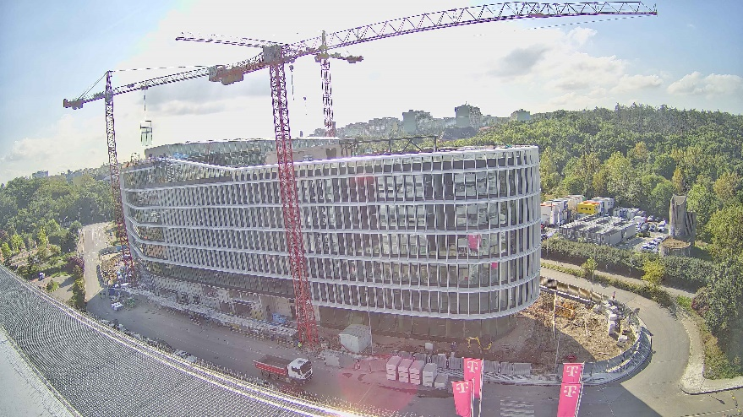

*In the photograph: Ongoing construction of the Roztyly Plaza office building. Its cladding is being completed.*

In addition to a pleasant working environment, the Roztyly Plaza building offers an underground parking lot for 330 vehicles, incl. preparation for charging stations for electromobility and 100 P+R spots. The employees will certainly welcome bike rooms for cyclists, because Roztyly Plaza is located on the main Prague/right embankment cycling path connecting all of Prague.

A complete visualisation of the project and more information on the entire locality are available on the website [www.roztylyplaza.cz](http://www.roztylyplaza.cz).

You can get more information and photographs in print quality from:  
Kristýna Samková**,** Head of PR and Marketing Department  
**PASSERINVEST GROUP, a.s.**Tel.: (+420) 221 582 111  
E-mail: [Kristyna.Samkova@Passerinvest.cz](mailto:Kristyna.Samkova@Passerinvest.cz)  
www.passerinvest.cz, [www.brumlovka.cz](http://www.brumlovka.cz)

Kamila Žitňáková  
**Crest Communications a.s.**  
Mobile: (+420) 725 544 106  
E-mail: [kamila.zitnakova@crestcom.cz](mailto:kamila.zitnakova@crestcom.cz)

**About the company:**

[Passerinvest Group](https://www.passerinvest.cz/) (hereinafter Passerinvest) is a purely Czech builder and investor. The company was founded by Radim Passer back in 1991 and has since then acquired an abundance of experience in the construction of office and commercial buildings, residential buildings and civic amenities. Since 1998, Passerinvest, as a responsible urban developer, has primarily been connected with [Brumlovka](http://www.brumlovka.cz) (BB Centrum) in Prague 4, which is one of the most successful and extensive urban projects not only in the Czech Republic, but throughout all of Europe. Another important project in the company’s portfolio is [Nové Roztyly](http://www.krcakzije.cz), a brownfield of the former slaughterhouses of the Interlov complex where, in the future, a place with pleasant housing with a large park should arise, complemented by services for the general public and an office function. The principles of urban construction and the long-term sustainable development of Prague and the Czech Republic are part of Passerinvest’s vision. Thanks to its responsible approach, Passerinvest has built a very good reputation both on a domestic and on an international level. This is not only to the credit of the quality of the realised projects and the high level of the provided services, but also to the sense of fair play, a customer approach and especially its responsibility to the society and the environment.