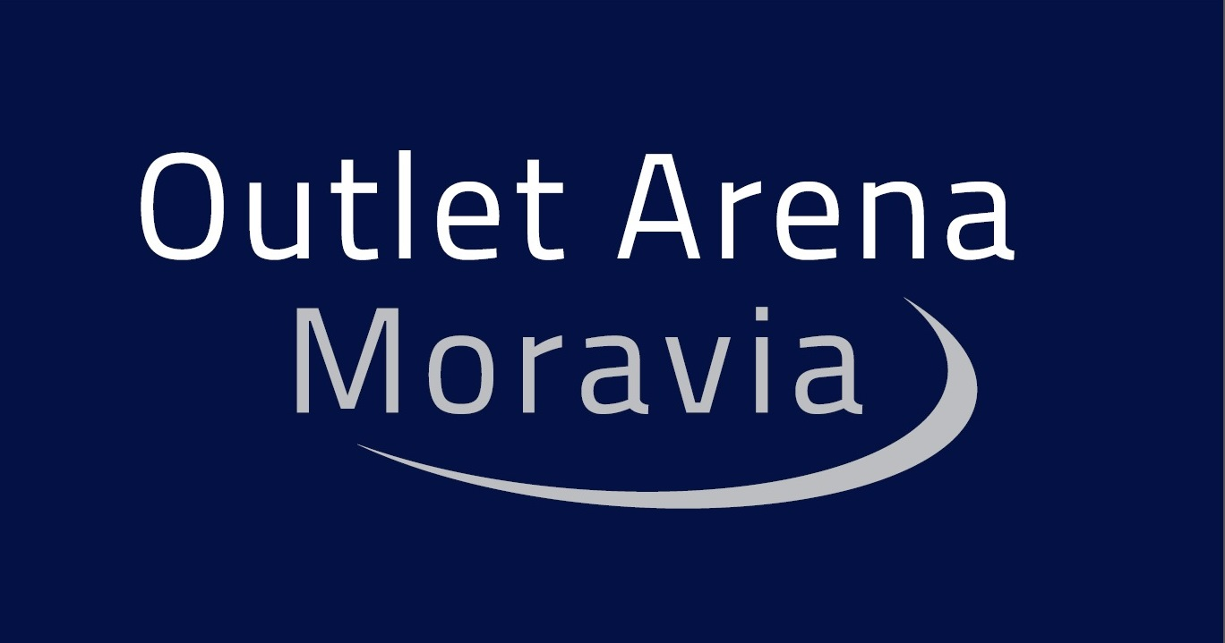

PRESS RELEASE November 20, 2017

tk development LAUNCHES CONSTRUCTION OF THE FIRST OUTLET CENTER IN THE MORAVIAN-SILESIAN REGION

TK Development, a real estate development company, has received a construction permit for building Outlet Arena Moravia. It will rise in the vicinity of the center of Ostrava, lying immediately adjacent to the D1 Motorway, on a vacant lot in Hlucinska Street (in proximity of two traffic arteries, with approximately 60,000 vehicles passing every day). Construction works are beginning these days, and Phase 1, offering 11,700 m² of total leasable area, is scheduled to open next autumn. A total of 70 shops will be available there, offering attractively priced products of the world´s famous brands, along with restaurants, cafés, and a children´s play area. Also, the center will have 800 parking places and those not traveling by car will be provided with shuttle buses from the center of Ostrava, with a mere ten-minute ride.

Outlet Arena Moravia, with its concept and design, has been inspired by the popular outlet center, Fashion Arena, built by TK Development in Prague-Sterboholy ten years ago. Architecturally speaking, it will resemble a big ring with a parking lot in the middle. The design has been produced by a studio known as dum konstrukce s.r.o. The region has been lacking a similar format outlet center, designed to sell very high-quality products from previous collections of leading foreign and domestic brands at significant discounts so far.

“Building on the great wealth of experience in construction and operation of outlet centers not only in Europe, but also in the capital city of the Czech Republic, we are bringing this proven format to Northern Moravia. We are delighted to say that our project is of extremely strong interest to prospective tenants: 70% of Phase 1 has been leased out,” said Mogens Pedersen, CEO, TK Development. “This achievement is certainly also due to the perfect location of the Arena, which will attract Czech customers from Ostrava and adjacent towns, along with those from neighboring Poland. Major employers operate in the region and a population of 3.2 million, with a strong buying power, live within 60 minutes´ driving range. Moreover, the nearby Beskydy Mountains rank among the most frequented mountain resort destinations in the Czech Republic. This is why we expect that the Arena will be attended by thousands of tourists as well.”
TK Development is a reputable property developer specialized in retail properties (shopping centers, retail parks and outlet centers) in Northern and Central Europe. The company is active in the real estate market in Denmark, Sweden, Poland and Czech Republic. Since established it has developed nine shopping centers in the CR, including Futurum in Ostrava and Hradec Kralove, Shopping Center Hana, Varyada Karlovy Vary, Shopping Center Fryda in Frydek-Mistek and Fashion Arena Outlet Center in Prague.

www.tk.dk
www.outlet-arena-moravia.cz

For more information contact:

Crest Communications, a.s.
Denisa Kolaříková Kamila Čadková
denisa.kolarikova@crestcom.cz kamila.cadkova@crestcom.cz
Mobile: 731 613 606 Mobile: 731 613 609

