## page1image56566208 **PRESS RELEASE** **12 November 2024**

**Urbanity real estate group places in the TOP 5 in the Association of Social Responsibility's prestigious ESG ranking**

**Thanks to its long-term orientation on sustainability and social responsibility, the Urbanity real estate group has placed among the top 5 companies in the category of small and medium-sized companies in this year’s** [**ESG ranking**](https://www.spolecenskaodpovednost.cz/esg-zebricek/)**, which is announced by the Association of Social Responsibility in cooperation with Forbes Czech Republic magazine. This prestigious ranking evaluates companies according to their approach to sustainability and the integration of ESG principles in their daily operations.**

Urbanity Group, known for building next-generation production campuses based on energy-efficient technologies, high user standards and close cooperation with local communities, reached the top of the category of small and medium-sized enterprises this year. This success confirms not only the high level of the implementation of sustainable strategies, but also Urbanity's ability to communicate its plans and results through its publicly available [ESG strategies and ESG reports](https://www.urbanity.cz/en/about-us/).

“*Innovations in the field of the materials used and energy efficiency in operations, including the production of our own green electricity, are essential in industrial development. At Urbanity, we believe that industrial campuses can be designed with the environment in mind while also providing user comfort. We combine unique architecture with renewable energy sources in order to create campuses that meet not only new regulatory requirements, but also the needs of modern companies and their employees. At the same time*, *we also respond to the needs of the local communities*,” stated **Roland Hofman**, co-founder and CEO of the Urbanity real estate group.

The 2024 ESG ranking, which is announced by the Association of Social Responsibility in cooperation with Forbes Czech Republic magazine, evaluated 79 companies from different sectors and, based on the completed questionnaires, assessed their approach to ESG principles according to the European Sustainability Reporting Standards (ESRS). Together with Urbanity, the companies Emedis, Good Sailors, Sonnentor and SPOJMONT OSTRAVA were also recognised in the category of small and medium-sized enterprises.

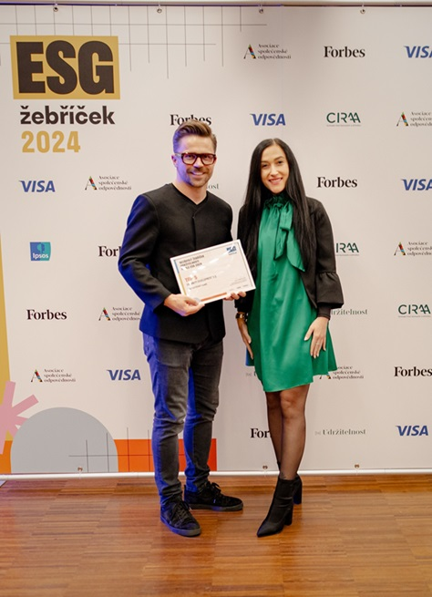

***URBANITY****is a real estate group that operates in the premium commercial real estate segment. Its aim is to build next-generation industrial campuses, where added value is created by an environment significantly oriented to the needs and comfort of their tenants. The concept of “made by Urbanity” projects meets the individual requirements of modern employers, and especially their employees, as well as the requirements for the ecological and energy sustainability of their own operations. The comprehensive urban solutions of the projects implemented by Urbanity Group, which is part of the M.L. Moran investment group founded in 1996, are unique on the Czech market and represent the future of the refinement of industrial sites and brownfields for the 21st century.*

**Crest Communications:**  
Kamila Žitňáková  
tel.: + 420 725 544 106

e-mail: [kamila.zitnakova@crestcom.cz](mailto:kamila.zitnakova@crestcom.cz)

**Urbanity:**  
Denisa Krejčová  
tel.: +420 737 019 424

e-mail: [denisa.krejcova@urbanity.cz](mailto:denisa.krejcova@urbanity.cz)